International Youth Camp
Schladming 2013

Response Form

Federation
Address

Tel. Nr.
Fax
Contact Person (First Name/Surname)
E-Mail (contact person)

Participant
First Name
Surname
Date of Birth (dd/mm/yyyy)
Address

Tel. Nr. (preferably mobile)
E-Mail
Passport Nr.

Date: Signature: Stamp:

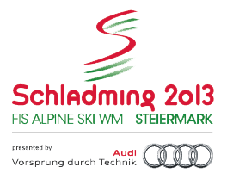
To the
Österreichischer Skiverband / Austrian Ski Federation
att: Mr. Tomas Woldrich phone +43-512-33501-21
Olympiastraße 10 fax +43-512-361998
6020Innsbruck / AUSTRIA e-mail tomas.woldrich@schladming2013.at

